|  |
| --- |
| Photo displaying partial image of two pie charts on a canvas-textured page |
| Requirements engineering  Blooming Marvelous Florist Blarney |
| |  |  |  | | --- | --- | --- | |  | 12/10/13 | Team 16 | |

Table of Contents

Project Drivers 2

The Purpose of the Project 2

Goals of the Project 3

The Stake Holders 4

The Client 4

Florist’s manager: 5

Florist’s staff: 5

The Customer 5

Other Stakeholders 5

Other stakeholder’s list: 6

Project Constraints 7

Mandated Constraints 7

Solution Constraints 7

Fit criterion: 7

The fix 7

Partner or Collaborative Applications 8

Paypal 8

Schedule Constraints 9

Budget Constraints 9

Costs: 9

Naming Conventions and Definitions 10

Relevant Facts and Assumptions 12

Business Rules 12

Assumptions 12

Functional Requirements 13

The Scope of the Work 13

Context Diagram 14

Work Partitioning 15

Specifying a BUC 16

Business Data Model 16

The Scope of the Product 17

Functional Requirements 17

Non-functional Requirements 18

Look and Feel Requirements 18

Usability and Humanity Requirements 18

Performance Requirements 18

Maintainability and support Requirements 18

Security Requirements 19

Data dictionary. 19

Project Issues 21

Open Issues 21

New Problems 21

Migration to the New Product 21

Risks 21

Costs 21

User Documentation and Training 21

Ideas for Solutions 22

Note: We used the Volere Requirements template. Which is copyrighted to the owners

# Project Drivers

## The Purpose of the Project

We picked Blooming Marvelous Florist in Blarney.

Cork Florists first opened its doors in 1968 and has been serving the people of Cork and surrounding areas ever since. They have a long standing tradition of pride in their work and make sure to stock only the highest quality flowers and accessories. Each of their florists are highly trained and experienced. They have daily deliveries to all parts of Cork and surrounding areas, also they are delighted to be associated with Interflora. Therefore they can arrange for your flowers to be delivered quite literally anywhere in the world.

They currently have a website:

http://www.corkflorists.ie/

The website has had been blooming two years ago but since the redesign the amount online use has dramatically dropped.

* The business mainly supplies flower products to a wide range of customers and in addition it offers small gifts that can be sent with or without flowers.
* Flower occasions include: anniversary, birthday, funeral etc.
* It provides deliveries of products to Cork and surrounding areas.
* Increased use of the internet allows for new development in online business.
* For florists it is a great opportunity to gain new customers.
* It would allow the florists to meet the customers’ needs with minimum effort.
* It would provide comfortable way of dealing with customers for florist’s staff.

The overall motivation is to increase sales by providing customers with a convenient, online service for the purchasing of flowers for themselves and others.

Blooming marvelous Florist wants to provide the customers with new functionality; being able to order at any time without having to go to the shop.

## Goals of the Project

Implementation of the project will fix the redesign which should produce a visible increase in the number of orders from customers and business revenue. It should also provide customers with a convenient, online service for the purchasing of flowers.

* Higher number of returning customers.
* Increased number of new customers.
* Better Payment Features
* More orders being placed.

To understand the effects and results these are having, Google Analytics will be used to provide reports at the end of each month.

## The Stake Holders

### The Client

The client is any of the staff, mainly known as the florist.

The client is also known as the following names:

### Florist’s manager:

Need to know business rules and constraints, is a source of domain’s specific information. Important for most stages of project.

### Florist’s staff:

Include the stylist, driver and teller.

To earn money at a profit and to create a service that will improve the business of the client and to reach the goal of the customer. While in the same sense to reach the goal of the client in performing the actions needed to make the customer’s goal happen.

So the goals are:

* Provide products to the customer.
* Increase the amount of transactions online and in store.
* Increase the amount of returning customers
* Increase profit.

When the customer gives the client there order they must check if they have the flowers, accessories, pots and the parts needed for to reach the customers goals.

### The Customer

The person intended to buy the product. In the case of the florist it’s anyone who wants to deal and purchase products from the client. Such as online using the website or offline using the traditional way of walking into the store or over the phone. The customer is ultimately responsible for deciding whether to buy the product from the client. The correct requirements can be gathered only if you understand the customer and his aspirations when it comes to using your product (What type of flowers and how many).

### Other Stakeholders

The roles and organizations who are affected by the product, or whose input is needed to build the product.

### Other stakeholder’s list:

* **Online customers:** Source of information on usability of the system (testing).
* **System developers**: Need to know technology aspects necessary for the project. Responsible for creating of the project.
* **System maintenance**: Need to be familiar with functional capabilities of the system. Will be responsible for providing updated business information in the system.
* **Automated payment system**: Project development has to adopt rules delivered by that system (PayPal).
* **The Bank:** In case of loans and repayments.

# Project Constraints

## Mandated Constraints

### Solution Constraints

The major problem with the website that is affecting most of it comes down to the fact with the payment. Not being able to have a different shipping address to the billing address.

Description: The payment method should allow for a different shipping address than that of the billing address.

Rationale: The Customer may or may not be able to want to ship flowers to a different address than them-self.

Fit criterion: When the Customer goes to put in the flowers, PayPal should allow the use of adding the input for a different shipping address.

The fix: This can be turned on in the settings of a PayPal seller as seen on my right. They click this setting to yes and the user will be allowed to ship to a different address.

## Partner or Collaborative Applications

Paypal

PayPal allows any business or individual with an email address to securely, conveniently and cost-effectively send and receive payments online.

The use of PayPal in this software is huge and the website is totally reliant on PayPal to handle all the payment methods.

They handle the sign in with PayPal, though normal credit card and the use of pay later.

## Schedule Constraints

The time constraints are the amount of time needed to check and update the system with new products and deals. Which includes updating the details for the transaction of each product with PayPal. As PayPal is a huge part of the system it will take twice as long to update both PayPal and the website which can be seen as failing.

The one deadline would be to have the online store up and running before Valentine's Day.

## Budget Constraints

### Costs:

The amount of cost to be placed on the online system is about the following:

300 euro for development and 100 euro in total for server costs.

The percent by using EBay is about 12 percent per taxation.

The cost of this system should never pass 1000 per year to run.

## Naming Conventions and Definitions

**Biedermeier** A tightly arranged nosegay consisting of concentric circles of various differently colored flowers. The blooms are wired into a holder, with one flower variety per ring.

**Cascade** A waterfall-like spill of blooms, often composed of ivy and long-stemmed flowers that is wired to cascade gracefully over the bride's hands.

**Classic bouquet** a dense bunch of blooms that can be anchored in a bouquet holder, wired, or hand-tied.

**Composite** A handmade creation in which different petals or buds are wired together on a single stem to create the illusion of a giant flower.

**Pomander** A bloom-covered ball suspended from a ribbon. Ideal for child attendants.

**Posies** Smaller than nosegays but similar in design, posies often include extras like ribbons or silk flowers. Perfect for little hands.

**Presentation** Also known as the pageant bouquet, this is a bunch of long-stemmed flowers cradled in the bride's arms.

**Dais** The centerpiece at the head table (where bride and groom are seated), which drapes to the front of the table for visual effect.

**Garden** Centerpiece featuring abstract wildflowers. The composition is airy and less full than other designs. Lisianthus, hollyhock, rambling roses, digitalis, and smilax are well suited to this arrangement style.

**Topiary** Flowers or foliage trimmed into geometric shapes, often resembling miniature trees or animals.

**Trellis** A woven wooden frame used as a screen or support for climbing plants and flowers.

**Wreath** A ring of flowers or other decorative materials that can function as centerpiece, headpiece, or door hanger.

**Florist stylish:** Person in charge of styling the flowers for the customers.

**Florist driver:** Person in charge of delivering the flowers to customers

**Florist teller.** Works at the till and takes orders and sets the task in moment.

**Customer:** Person who wants to buy a product (Flowers).

**Florist Manager:** Owner of the shop.

**Google Analytics:** online usage statistics provider.

**Paypal:** online transaction provider.

## Relevant Facts and Assumptions

The redesign was done two years, the major problem is the payment option doesn’t allow the customer to ship the order to a different address than the billing address. Used to get about 15 orders a month, now get one if lucky.

There are usually three major sources of fresh flowers for retail florists:

* local growers
* local wholesalers
* Flower auctions.

## Business Rules

* Online payment method must be PayPal or credit card.
* List of accepted credit cards: Visa, MasterCard, American Express, Discover
* Order must be ordered before 1pm for same day delivery.

## Assumptions

The assumptions are to be made on the back information on the website as the owner during the interview didn’t know how or what was happening in the background of the website or to even add or update products.

All this was outsourced to a local student. Who wasn’t available for an interview.

# Functional Requirements

## The Scope of the Work

The current situation so far is that blooming marvelous Florist in Blarney has a website called http://www.corkflorists.ie.

They have also been running two shops in Ireland since 1968. The stores are located in Blarney Co. Cork and Tower, Blarney Co. Cork.

This business used to have a very good online store with loads of orders, but that changed due to an update two years ago. The main problem is that when it comes to the PayPal function of sending flowers to a different address than that of the billing address.

* From the interview the owner also told us that users found the website boring but that is a nonfunctional requirement.
* The PayPal fix is done by changing a setting in PayPal’s settings. By clicking all shipping address.

## Context Diagram

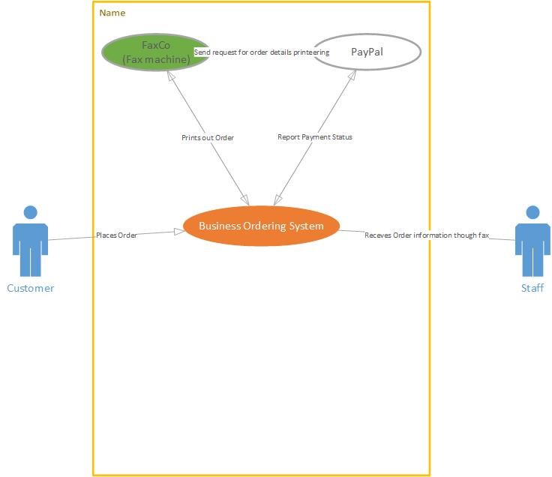

## Work Partitioning

|  |  |  |
| --- | --- | --- |
| Event Name | Input and Output | Summary of BUC |
| Payment provider emails order details | Confirmation(out) | The staff owner receives an email and fax after the buyer pays for item. |
| Owner updates product: | Details of product(in) | To update products on the website. |
| Owner removes product: | Details of product removed(out) | To add products on the website. |
| Owner adds product | Details of new product(in) | Customer wants to buy products online. |
| Customer places online order: | Details of order(in)  Order confirmation(out) |  |

## Specifying a BUC

Please view Appendix: Use Case

## Business Data Model

Please view Appendix: Model

## The Scope of the Product

The current situation so far is that blooming marvelous Florist in Blarney has a website called http://www.corkflorists.ie.

They have also been running two shops in Ireland since 1968. The stores are located in Blarney Co. Cork and Tower, Blarney Co. Cork.

This business used to have a very good online store with loads of orders, but that changed due to an update two years ago. The main problem is that when it comes to the PayPal function of sending flowers to a different address than that of the billing address.

* From the interview the owner also told us that users found the website boring but that is a nonfunctional requirement.
* The PayPal fix is done by changing a setting in PayPal’s settings. By clicking all shipping address.

## Functional Requirements

* System should provide navigation menu divided into categories provided
* System should display window with example items
* At any page user should be able to view his cart
* System should provide remove item from cart option at any time before payment is done
* System should provide going back to shopping option at any time when any item is in the cart
* System should provide alternative shipping address
* System should provide PayPal and credit card (Visa, MasterCard, Discover, American Express) payment options

# Non-functional Requirements

### Look and Feel Requirements

* Stand within the standard for cms design.
* That the design should reflect the real world of flowers
* Content should be displayed on plain clear background

### Usability and Humanity Requirements

* System is intended to work on Firefox, Chrome, Opera and internet Explorer browsers
* Everything must be accessible from 2 clicks away.
* Finish buying flowers in five steps or less
* The system should be easily used by people with basic computer knowledge.

### Performance Requirements

* System is to operate 24 hours per day, 365 days per year
* System should be able to hold information details for minimum 200 items
* System should be able to process up to 1000 orders at the same time

### Maintainability and support Requirements

* System should allow for updating items details without interrupted work
* System is going to work on Windows 7 operating system but must be compatible with previous system’s versions

### Security Requirements

* Encrypted credit card information
* Encrypted personal information
* System should not send payment details without all required details entered
* Only owner should be able to insert/update/modify information stored about items

Data dictionary.

|  |  |  |
| --- | --- | --- |
| Name | Content | Type |
| Customer | name + email + phoneNo + CustomerNo | Class |
| Order | OrderNo + custNo + listofItems + totalPrice + shippingAddress |  |
| Item | ItemDescription + itemNo + itemPrice |  |
| Payment | totalPrice + paymentMethod + orderNo + custNo |  |
| Conformation | paymentDetails + emailAddress |  |
| Owner | None |  |
| ChangeNo |  | Attribute/Element |
| Faxco |  |  |
| Name |  |  |
| Email |  |  |
| phoneNo |  |  |
| CustomerNo |  |  |
| OrderNo |  |  |
| CustNo |  |  |
| listOfItems |  |  |
| TotalPrice |  |  |
| shippingAdress |  |  |
| ItemDescription |  |  |
| ItemNo |  |  |
| itemPrice |  |  |
| paymentMethod |  |  |
| paymentDetails |  |  |
| emailsAddress |  |  |
| attributtedChanged |  |  |
| abbiteuedUpdated |  |  |
| Ordering Flowers | Customer + Order + Payment | Dataflow |
| Email | {Payment + faxco + ower} | Dataflow |
| Update | {Owner + change + item} | Dataflow |
| Insert | {Owner + change + item} | Dataflow |
| Delete | {Owner + change + item} | Dataflow |

## Project Issues

Open Issues

That PayPal will change these terms and connections, it’s a problem that may or may not happen. This will become clearer and will be given plenty of notice from PayPal for us to deal with it as needed.

### New Problems

There was no new problems to report as of the writing of this document

### Migration to the New Product

Migration to the new Product will be quite simple and straight forward. It will have a slight down time of about 2-3 hours in total for the website.

### Risks

There is no risks involved with the new project. Only improvements.

### Costs

Web Developer: 100 euro.

User Documentation and Training

Please View User Guide Appendix

### Ideas for Solutions

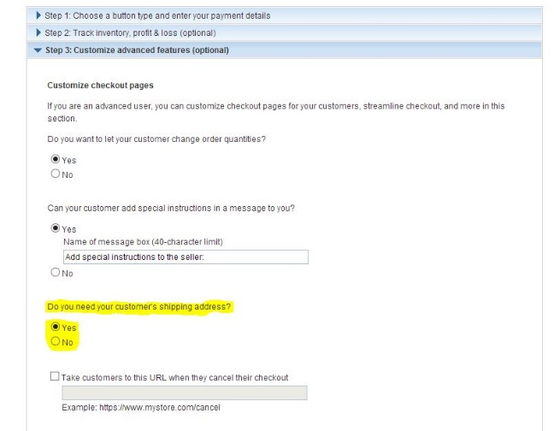This can be turned on in the settings of PayPal seller as seen on my right. They click this setting to yes and the user will be allowed to ship to a different address.